

**Virtual Agent ServiceNow**

Author of Document: Abhijeet Singh

Date: September 2023

Project Name: Work-From-Home Starter Pack

**Project Name:** Work-From-Home Starter Pack

**Project Description:**

In light of the COVID-19/Coronavirus health crisis, organizations across the globe are experiencing a shift to a work-from-home (WFH) model of operations for their employees. With this, there is a critical need for organizations to mobilize quickly to support the infrastructure of a digital workforce. This Virtual Agent Work-From-Home Starter Pack offers a quick start and templates to:

1. Keep employees up to date on how the organization is responding to the health crisis (FAQ).
2. Provide relevant resources as employees transition to work-from-home, including troubleshooting tips and guides for critical IT collaboration tools.
3. Enable employees to submit tickets for help with IT-related issues.

The Virtual Agent WFH Starter Pack consists of a set of sample topics with these key functionalities:

* Addressing employee questions through a COVID-19 FAQ
* Troubleshoot popular collaboration services including Zoom, Cisco Webex, Slack, and Microsoft Teams
* Creating IT tickets for unresolved issues

**Branding:**

|  |  |
| --- | --- |
| Custom branding is used to alter the Virtual Agent's default appearance. |  |

**Greetings:**

|  |  |
| --- | --- |
| Default Greetings provided by ServiceNow were used. |  |

**Topics:**

* **Name:** COVID-19 FAQ

**Description:** Common Frequently Asked Questions that employees may ask about the crisis.

**Flow:**

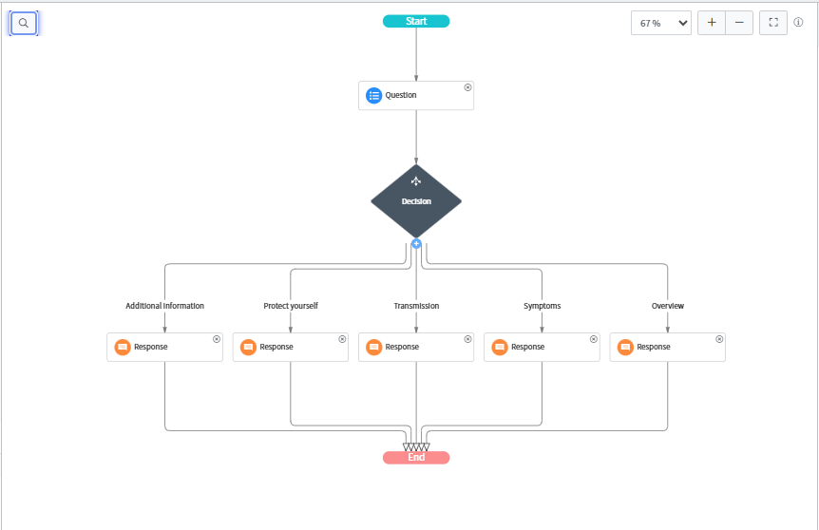

* **Name:** Troubleshoot Your Zoom Meeting

**Description:** A guide for hosts to resolve common issues encountered when hosting a meeting using Zoom.

**Flow:**

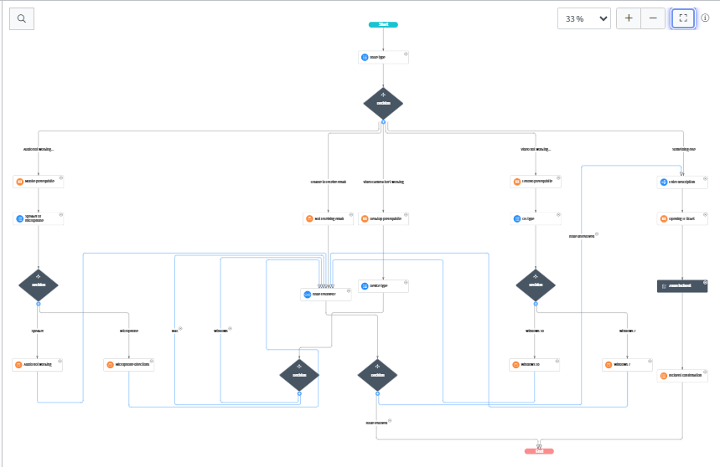

*NOTE: Every flow includes the flow from the node Issue Resolved, thus we can make it a Topic Block and reuse it throughout all flows.

* **Name:** Troubleshoot Your Cisco Webex Meeting

**Description:** A guide for hosts to resolve common issues encountered when hosting a meeting using Webex Meetings.

**Flow:**

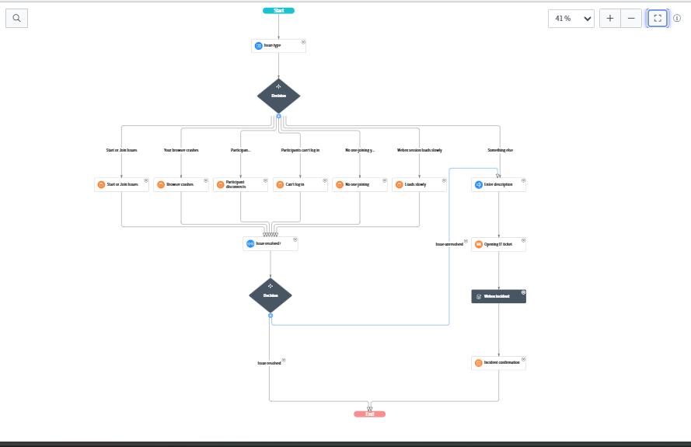

* **Name:** Microsoft Teams

**Description:** A guide for Microsoft Teams users to resolve common issues encountered using Microsoft Teams.

**Flow:**

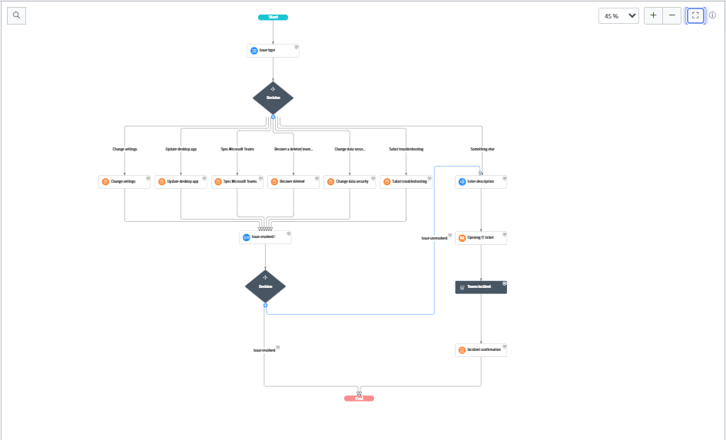

* **Name:** Troubleshoot Your Slack Connection

**Description:** A guide for Slack users to resolve common connection issues.

**Flow:**

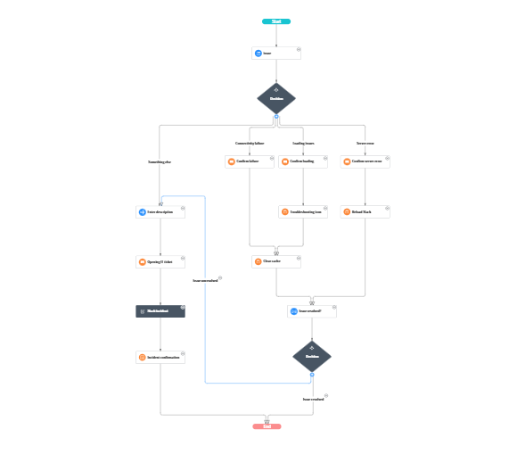

**NLU Model**

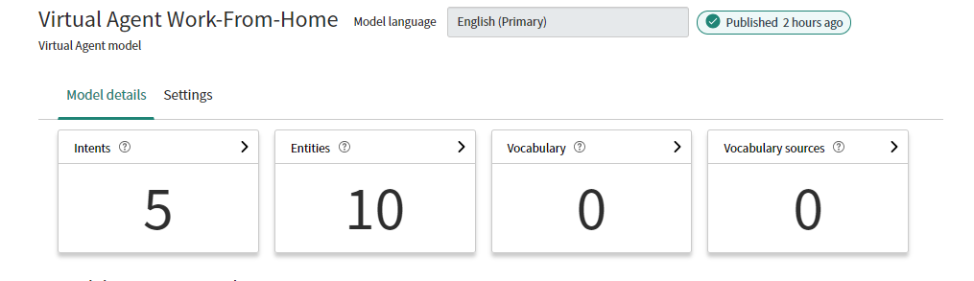

**Intents**

* COVID-19 FAQ

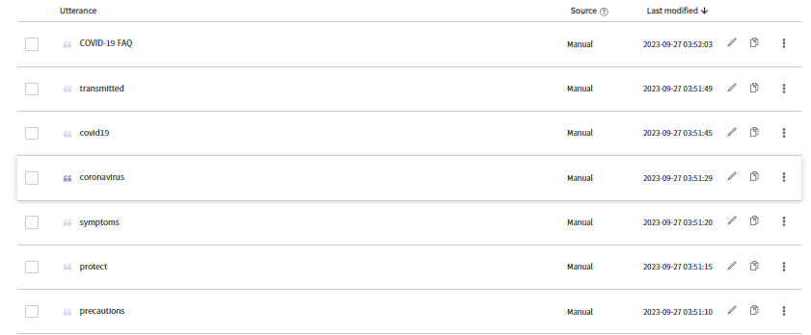

* Troubleshoot Your Zoom Meeting

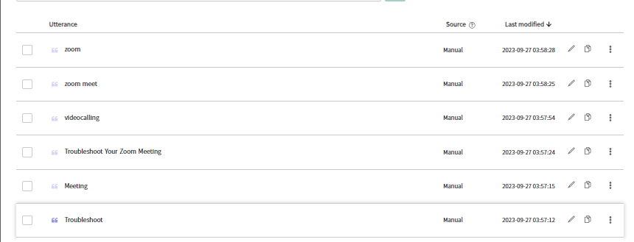

* Troubleshoot Your Cisco Webex Meeting

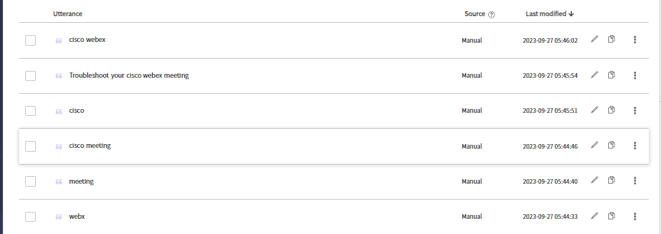

* Microsoft Teams

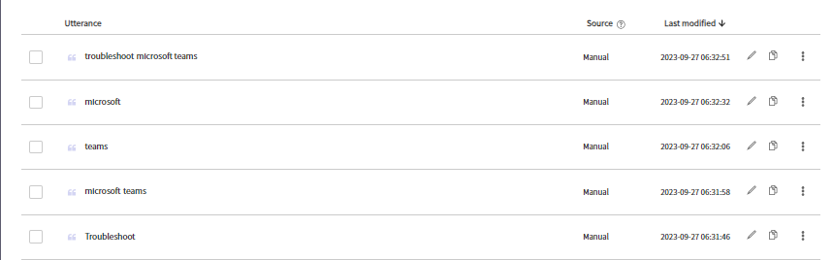

* Troubleshoot Your Slack Connection

